**EXPERIMENT NO: 10**

**DEVOPS**

**AIM:** To install and configure pull based Software Configuration Management and provisioning tools using Puppet.

**LO:6** – Synthesis software configuration and provisioning using Ansible.

**THEORY:**

**Puppet Introduction:**

* Puppet is an open-source DevOps system management tool. It is used to centralize and automate the configuration management procedure. This tool is developed using Ruby DSL (domain-specific language). Puppet tool deploys, configures, and manages the servers.
* This tutorial will help in understanding why Puppet is so popular and what makes it unique when compared to other configuration management tools. All the examples in this tutorial are tested. This code can be used with any puppet configuration by changing the current defined names and variables
* Puppet is a DevOps configuration management tool. This is developed by Puppet Labs and is available for both open-source and enterprise versions. It is used to centralize and automate the procedure of configuration management.
* This tool is developed using Ruby DSL (domain-specific language), which allows you to change a complete infrastructure in code format and can be easily managed and configured.
* Puppet tool deploys, configures, and manages the servers. This is used particularly

**Features of Puppet:**

Following are the features of Puppet:

1. **Platform Support**

Puppet is compatible with all platforms that support Ruby, like Microsoft Windows, Linux, MacOS X, etc.

1. **Scalable**

The puppet was developed in 2005; therefore, many different organizations, including medium and large, have deployed Puppet, and hence its scalability is very large.

1. **Documentation**

Puppet provides a large number of well-developed wiki pages with detailed documentation.

1. **Idempotency**

Unlike other configuration management tools, in Puppet, we can safely run the same set of configurations multiple times on the same machine. Means, after deploying a configuration on any machine, the puppet keeps verifying those configurations in certain intervals.

1. **Open-Source**

A puppet is an open-source tool, and because of this feature, it is easy to extend it to build custom libraries and modules.

1. **Reporting Compliance**

The enterprise version of the puppet supports graphical reporting with the help of this you can simply visualize the infrastructure, communicate, and quickly respond to the modifications. It provides you the real-time visibility into the effects of changes, which allows you to see what's going on your infrastructure.

1. **Cost-Effective**

When you have many numbers of systems and want to make some minor code changes, then Puppet helps to reduce the effort and cost.

1. **Faster**

Puppet allows DevOps professionals and System Administrators to work more quickly and effectively.

1. **Growing Fast**

Today, many companies have adopted puppet to manage their infrastructure, such as Google, Red Hat, AT&T, Spotify, AON, US Air Force, etc.

**OUTPUT:**

Step 1: Sign in into AWS account and launch an instance while launching instance select ubuntu machine and number of instances will be 2.

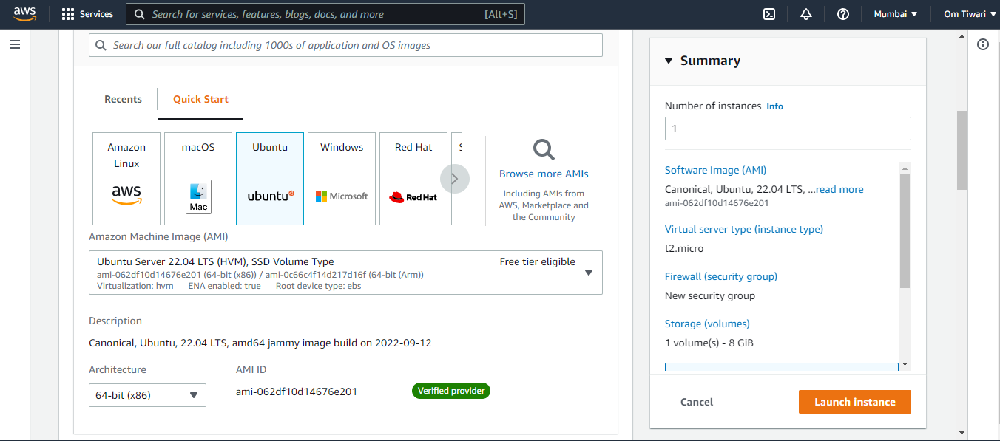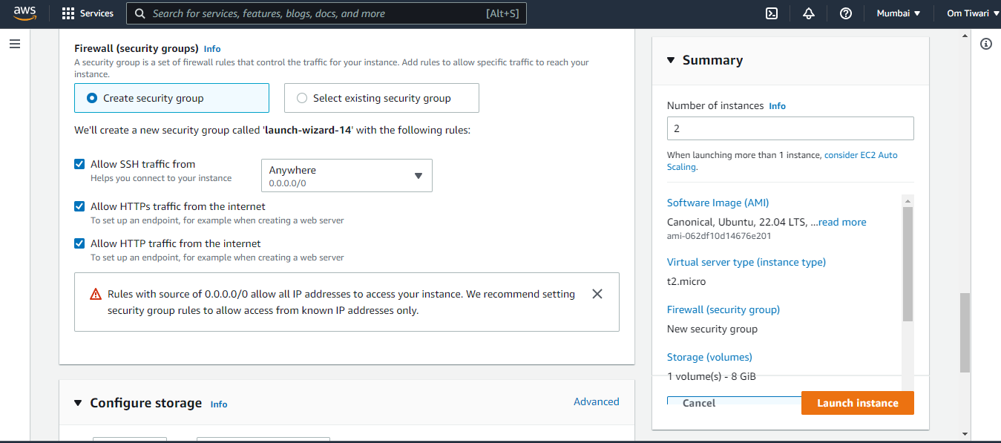

Rename instance to Master and Agent.

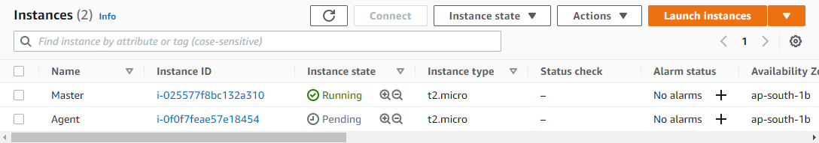

Step 2: Connecting master to puTTy.

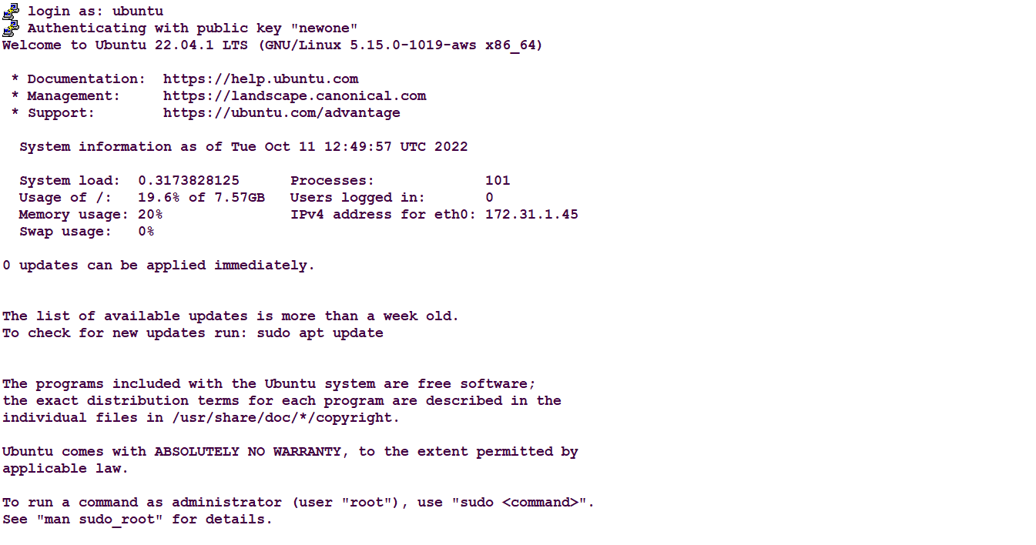

And update the machine.

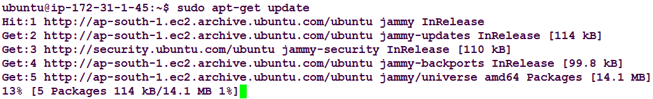

Step 3: Connecting Agent to puTTy and updating the machine.

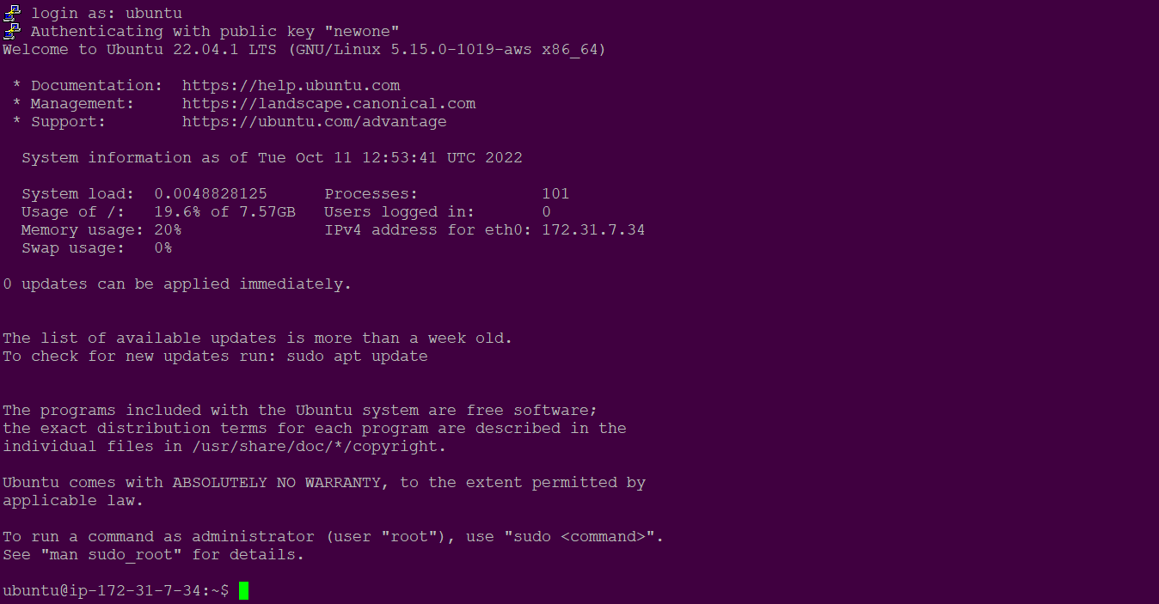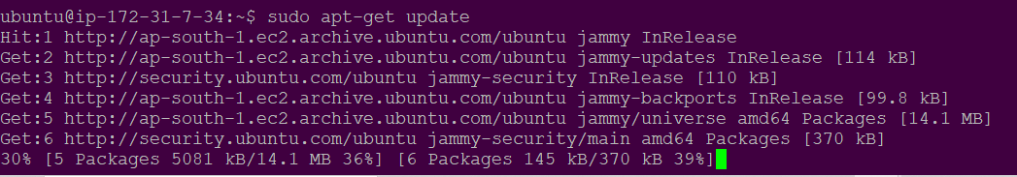

Step 4: To download and unzip the puppet file and install puppet-master.

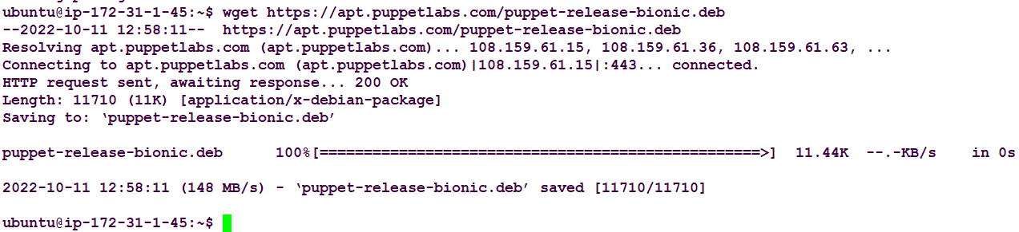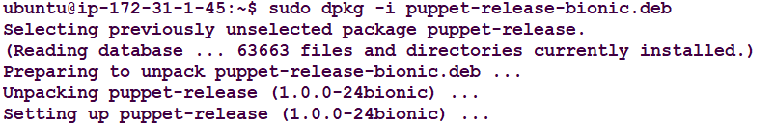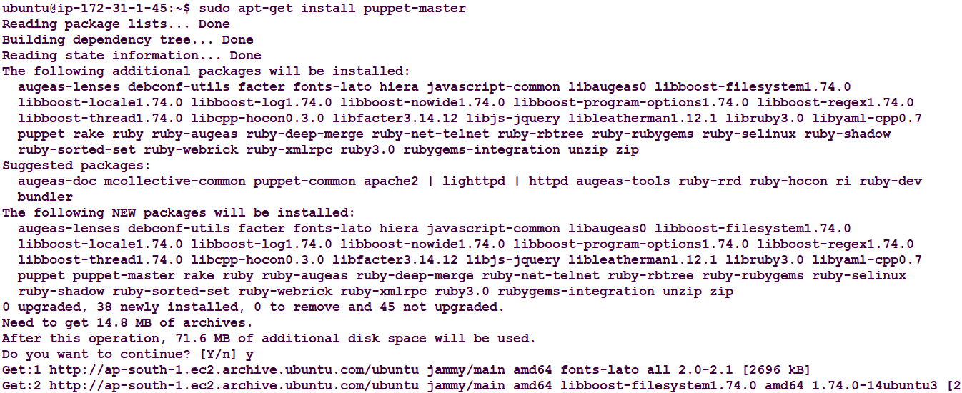

Step 5: Check the status of the puppet master service (press q to exit).

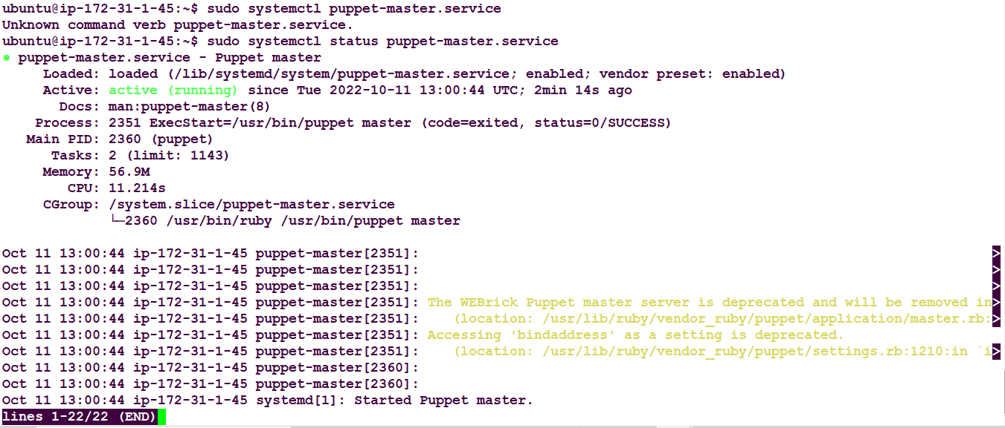

Step 6: Configure the puppet master file.

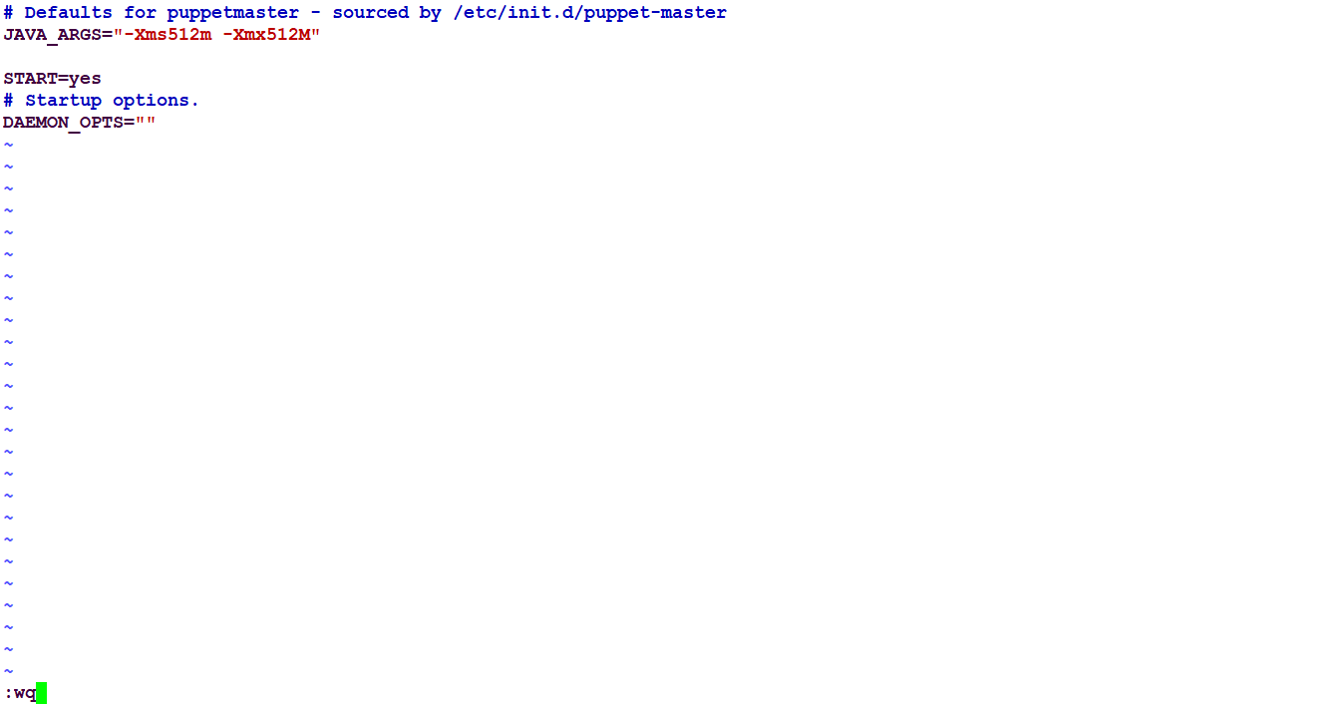

Step 7: Now restart the puppet master service.



Step 8: Now we open 8140 port through which the puppet Communicate.



Step 9: Setting up puppet-agent

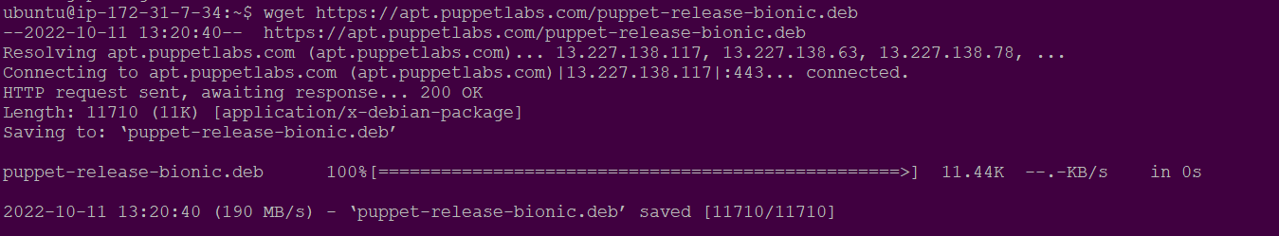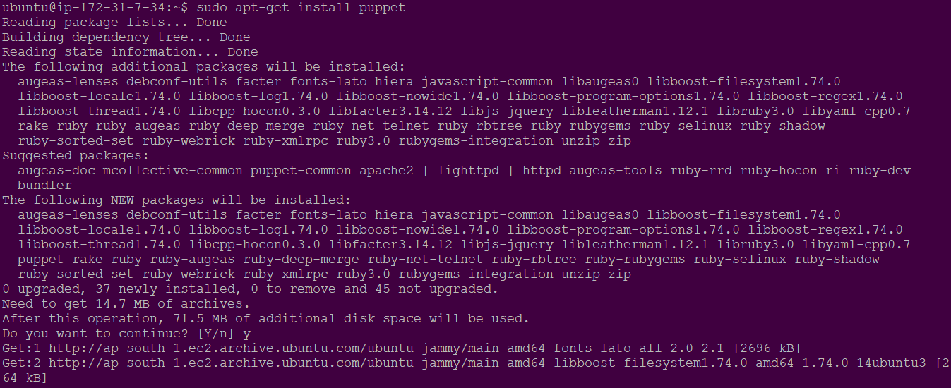

Step 10: Mention the Master IP address in both of the machine’s hosts file.

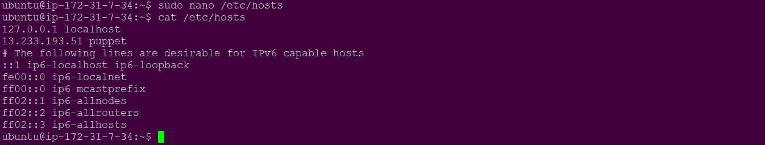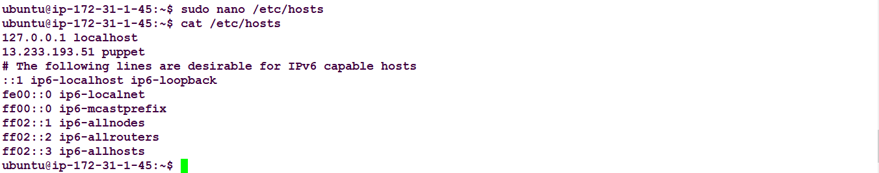

Step 11: Start and Enable the puppet on the machine.



Step 12: Check for the certificate and sign the certificate.

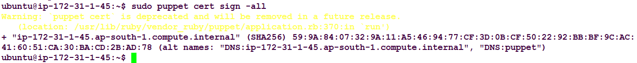

Step 13: Configuring the master and slave interaction by making changes in defined directory.

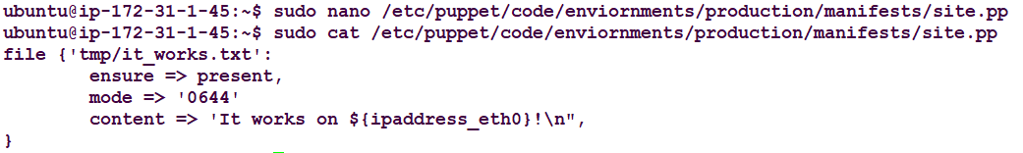

Step 14: Restart puppet-master



Step 15: Agent will request for the changes because it is based on the pull mechanism.



**CONCLUSION:**